**Introduction**

**Overall Description**

*Product perspectives*

Product : self-sufficient vertical distance measurement system.

The product is to be installed under a truck driving on a construction site. The measurement is intended to warn the driver before he comes into contact with the ground (ie. an object was detected in a range).

*Product features*

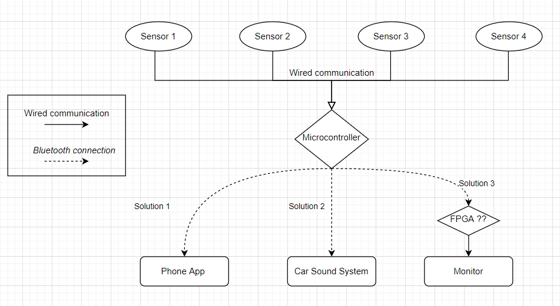

***User description***

Users will be professional truck drivers.

***Operating Environment***

Product will be used outdoors. Sensors will be mounted under the truck (near the wheels).

***Design and Implementation Constraints***

Ideal size of the finished box: 50 x 50 mm (as small as possible)

Temperature range (box): -10°C - +60°C ***(high temperatures causes variation in the speed of sound)***

monitor (max. 100 x 100 mm)

*Assumption and Dependencies*

The car sound system has Bluetooth.

The car radio interface provides an USB plug.

The conductor will use his own phone.

**System features**

*Functional Requirements*

several sensors can be queried at the same time if required.

Precision: 10mm - 80mm; Accuracy 10mm

Power supply: battery (rechargeable) or alternatively battery (CR2032)

1. Phone App: read out via a simple app (Android + iOS).

2. Car sound system: be played back acoustically via a Bluetooth connection to the car radio (provided the car radio has Bluetooth).

3. Monitor: read out and displayed on a small additional monitor (max. 100 x 100 mm). The monitor is powered by USB. This solution must work wirelessly and should be able to be switched on and off.

**External interface requirements**

*User interfaces*

The product can output data measurements as desired between the 3 solutions:

1. Phone App: The individual products (some drivers use several sensors at different points on the truck at the same time) are to be displayed graphically with distance cm. The individual products can be assigned their own name in the app.

2. Car sound system: The acoustics should be similar to parking sensors (interval beeping). The smaller the distance, the faster the respective sensor beeps.

***For distinction: A voice message says which sensor is involved ???***

3. Monitor: read out and displayed on a small additional monitor (max. 100 x 100 mm). The monitor is self-sufficient and can be freely installed anywhere in the driver's cab (e.g. glued or with a magnet). Graphical interface will be showing distance values measured by sensors.

*Hardware interfaces*

*Software interfaces*

*Communication interfaces*

**Nonfunctional requirements**

*Performance Requirements*

*Safety Requirements*

*Security Requirements*

*Software quality requirements*

**This system requirements specification document is explicit. Any requirement not mentioned in this document is not part of the prototype project. Accordingly, contracting parties can make changes on requirements only against written approval.**